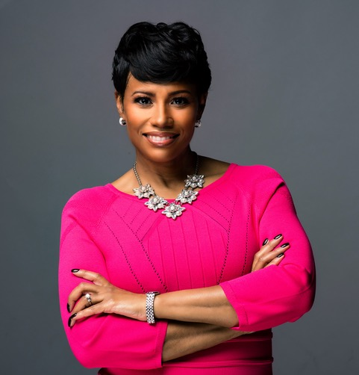

Sherlaender “Lani” Phillips
Vice President, US Channel Sales
Microsoft Corporation
As Vice President of Microsoft’s US One Commercial Channel Sales Organization. Lani Phillips is responsible for driving digital transformation across our customers in Commercial, Mid-Market and Regulated Industries in the United States with our partner ecosystem. With responsibility for a $30B+ business she is responsible for accelerating the Co-Selling partnership which enables our partners and Microsoft to drive joint sales pursuits, revenue and ultimately customer success. Our partners help drive cloud sales and consumption across all four solution areas: Modern Workplace, Business Applications, Apps & Infrastructure and Data & AI. Lani is very passionate about transforming businesses in this new digital era, leading cultural transformations in an inclusive way while helping our customers & partners be successful while building high performing and engaged organizations. She frequently seeks out opportunities to share and learn new ways of driving this change at scale.
Prior to this role she served as the Chief Transformation Officer for our Enterprise Commercial business. Where she was responsible for leading one of the largest digital “sales” transformation in our company’s history. She was also a sought-after speaker to share with our customers firsthand our experience to help aide in their own digital transformation journey. Lani also was the General Manager for our Midwest Region in Enterprise responsible for a $1.2 Billion business. Where her organization was recognized for delivering exceptional results. She also served in a host of other senior leadership roles around the US.
Lani, her husband James and son Brayden (10) reside in the Chicago/Naperville area. In her spare time, she enjoys spending quality time with her boys, cooking and writing her first leadership book which will enable her to add “author” to her bio soon enough.

