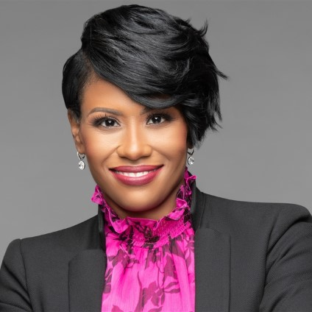
Sherlaender “Lani” Phillips | Long Biography
Lani Phillips brings over 20 years of experience in inclusive leadership and transformation management in the technology industry and is a recognized leader within Microsoft. She is a sought-after speaker on a wide range of business topics such as inclusive leadership and collaborates with leaders around the world to drive business and cultural transformation at scale. Lani currently serves as Vice President of Channel Sales at Microsoft Corporation in the US One Commercial Partner (OCP) organization.
As VP of Channel Sales, Lani leads her team of Enterprise and Territory Channel Managers in supporting the digital transformation of customers in Commercial, Mid-Market, and Regulated Industries by accelerating co-selling partnerships and collaborating with Microsoft partners representing a $30B business.
Lani continues to be an agent for change within Microsoft and is currently embarking on driving tighter integration between Microsoft’s channel partners, field sales organization, and customers leading our Partner Field Integration initiative.
Previously, Lani has held numerous senior leadership roles across Microsoft, transforming business and cultivating high-performance teams.
As Chief Transformation Officer for Microsoft’s Enterprise Partner Group, Lani led one of the largest global sales transformations in Microsoft history. Her work is credited with setting Microsoft up to thrive as a mobile-first, cloud-first thought leader.
Lani also earned recognition for excellence in a role which oversaw Microsoft sales, marketing, services, and partner channel efforts for the Midwest Region. Her team ranked first across the US for driving revenue and growth in a region representing $1.2B business for 130 of our largest and top enterprise customers.
Complementing her work in the technology industry, Lani founded and heads a board of all-female executives for Women Executives in Channel Advisory Board. They are focused on creating more opportunities for women in the workplace and driving equity of share. She also serves on the International Association of Microsoft Channel Partners (IAMCP) D&I Advisory Board. She was also recognized on the CRN 2020 Women in Channel list featuring the top women in the channel.
Lani received a Master of Business Administration degree with distinguished honors from the University of Texas at Dallas with a concentration on Global Leadership, and holds a Bachelor of Science degree in Information Systems.
Lani has a passion for inspiring, transforming, and growing leaders. She is currently writing her first leadership book and looks forward to adding “author” to her bio in 2021. Lani, her husband James, and son Brayden (10), make their home in the Naperville, IL area.

