Sherlaender “Lani” Phillips | Short Biography
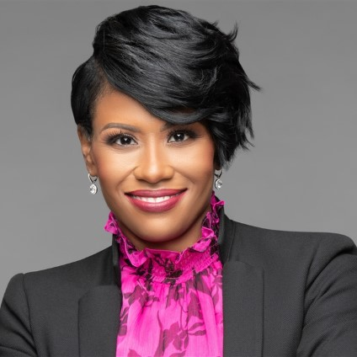
Lani Phillips brings over 20 years of experience in inclusive leadership and transformation management in the technology industry as a recognized leader within Microsoft. She is a sought-after speaker and collaborates with leaders around the world to drive business and cultural transformation at scale.
Lani currently serves as Vice President of Channel Sales at Microsoft Corporation in the US One Commercial Partner (OCP) organization. Her team supports our customers’ digital transformation efforts by accelerating co-selling partnerships with Microsoft partners representing a $30B business. Previously, Lani has held numerous senior leadership roles across Microsoft, including Chief Transformation Officer for Microsoft’s Enterprise Partner Group, where she led the largest global sales transformation in Microsoft’s history. Prior to that Lani led the commercial business in the Midwest Region with responsibility for sales, services and partners focused on accelerating our customers; digital transformation and deliver on both short-term and long-term financial goals and responsibilities representing a $1.2B business with some of our top enterprise customers.
Complementing her work in the technology industry, Lani founded and heads a board of all-female executives for Women Executives in Channel (WEC). They are focused on creating more opportunities for women in the workplace and driving equity of share. She also serves on the International Association of Microsoft Channel Partners (IAMCP) D&I Advisory Board. She was also recognized on the CRN 2020 Women in Channel list featuring the top women in the channel.
Lani received a Master of Business Administration degree with distinguished honors from the University of Texas at Dallas with a concentration on Global Leadership and holds a Bachelor of Science degree in Information Systems. Lani has a passion for inspiring, transforming, and growing leaders. She is currently writing her first leadership book and looks forward to adding “author” to her bio in 2021.

