Sherlaender “Lani” Phillips | Long Biography
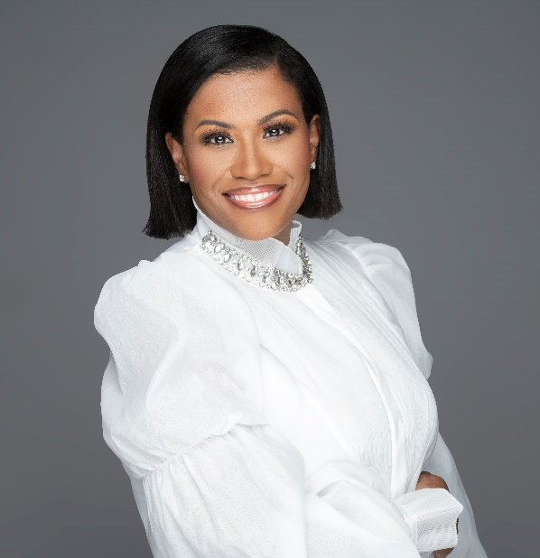
Lani Phillips is Vice President of Global Partner Solutions, US Channel Sales for Microsoft Corporation. With responsibility for leading the US Channel Sales strategy and execution in the US supporting our customers digital transformation agenda with our partner ecosystem. Accountable for revenue, profitability, and partner satisfaction across commercial, mid-market and small business customers.
In addition to leading the channel sales organization, Lani is the executive sponsor for the company’s work to address systemic racial injustice – with efforts targeted at increasing the number of African American and Black representation in the partner ecosystem, driving $1B+ economic growth and generational wealth building opportunities for Black-owned businesses through an industry-leading partner program.
Prior to this role Lani served as Chief Transformation Officer for Microsoft’s Enterprise Partner Group, where she led the largest global sales transformations in the company’s history. Lani has successfully led numerous teams across the business. She has an extensive record of cultivating high performance teams and transforming businesses.
She was CRN Power 100 Women of the Channel in 2021 and Top 10 Most Influential Women in the Cloud. In 2020 she received recognition as Executive Impact Award by Linkage and Global Minded Inclusive Leadership Award. Lani also founded the Women Executive Channel Advisory Network (WECAN) focused on empowering and elevating women leaders in the technology industry. WECAN became a non-profit organization, and she is now serving on the non-profit board. She is highly sought after for her unique business perspective.
Over the years, Lani has developed a reputation for being a transformational leader who is committed to empowering people and driving for results. Complementing her work in the technology industry, Lani’s passion for mentoring has grown into a digital platform Modern Mentoring dedicated to bringing together collective voices, sharing key learnings about how to flourish in corporate spaces. Helping her mentees be successful, accomplish their career goals and push beyond any self-imposed limiting beliefs.
Lani received a Master of Business Administration degree with distinguished honors from the University of Texas at Dallas with a concentration on Global Leadership and holds a Bachelor of Science degree in Information Systems. As a perpetual student of leadership and an emerging author, Lani is committed to inspiring, educating, and growing leaders.

