Sherlaender “Lani” Phillips | Short Biography
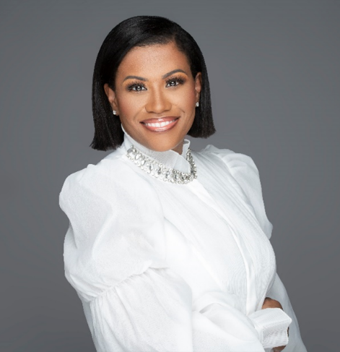
Lani Phillips is a seasoned technology executive with over 20 years of experience in the technology industry. Lani currently serves as Vice President of US Channel Sales at Microsoft. With responsibility for leading the US Channel Sales strategy and execution in the US supporting our customers digital transformation agenda with our partner ecosystem. Accountable for revenue, profitability, and partner satisfaction across commercial, mid-market and small business customers.
She was the recipient of the CRN Power 100 Women of the Channel in 2021 and Top 10 Most Influential Women in the Cloud. In 2020 she was awarded the “Executive Impact Award” from Linkage, the 2020 Global Minded “Inclusive Leader Award,” and was included on the CRN 2020 Women in Channel’s “Leading Fearlessly in a Time of Crisis” List, along with the top women in the channel.
Complementing her work in the technology industry, Lani founded the Women Executive Channel Advisory Network (WECAN) in 2019. The board is comprised of all female executives, with a focus on creating more opportunities for women in the tech industry. She also serves on the International Association of Microsoft Channel Partners (IAMCP) D&I Advisory Board. Lani has a passion for inspiring, transforming, and growing leaders. In 2021, she launched “Modern Mentoring with Lani Phillips,” a digital platform designed with the intention of sharing wisdom globally and making it accessible for anyone looking to thrive in corporate spaces.

